Before an Event, the first thing that has to happen is the creation of a dummy item for that event; this is what the one for All-WALS looks like in Workflows:
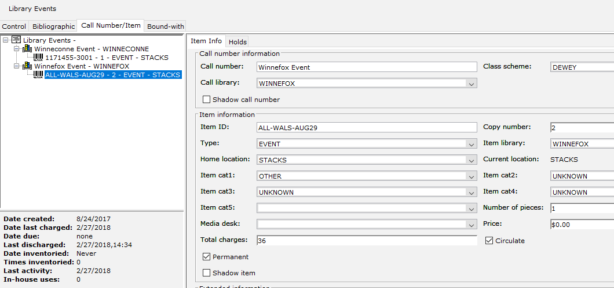

- All events are located on the general title “Library Events”.
- Each library using MobileCirc to track events needs to create a single Call Number for their library: ex, “Winnefox Event”.
- Each event is created as a new item under the library’s Call Number. The Item ID can indicate what type of event it is, using both letters and numbers (“ALL-WALS-AUG29”). Item IDs must be unique across the system.
- For item information:
  - Item TYPE: EVENT. This is what allows it to be used in MobileCirc as an event.
  - Item Cat4: UNKNOWN; Home Loc: STACKS; Item Cat 1: UNKNOWN; Item Cat 2: UNKOWN; Item Cat 3: UNKNOWN. This allows us to exclude or account for it in monthly stats.
  - If you want to differentiate between Adult and Juvy programs, you can set the Item Cat 2 to the appropriate value.

With the item created, log into MobileCirc, and go down to the Setup tab:
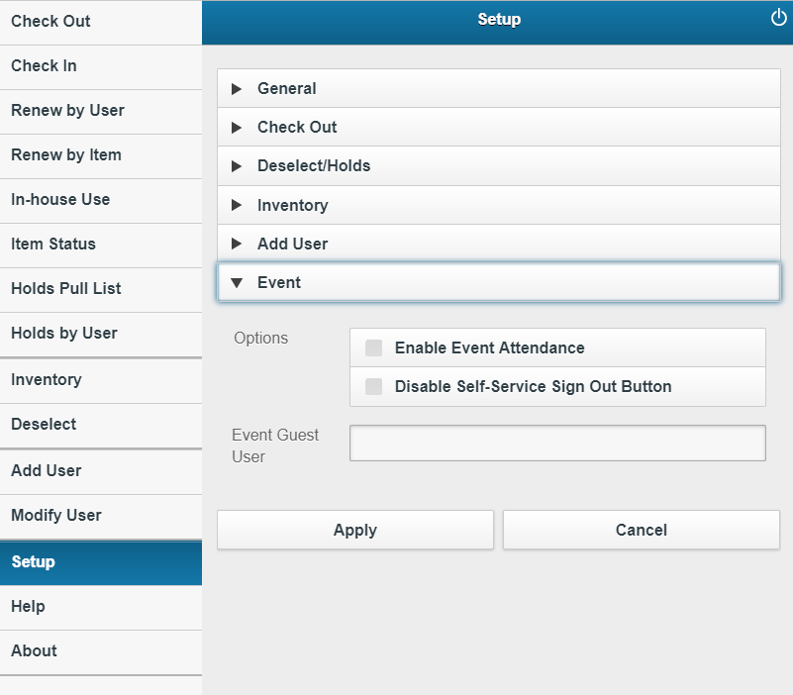

Check “Enable Event Attendance”.

If you like, you can check the “Disable Self-Service Sign Out Button” if you like. If you do this, then if you use the Self-Service feature, the “Log Out” button in the upper right-hand corner is removed, so that patrons can’t accidentally sign out of MobileCirc.

In the “Event Guest User” field, enter “GUEST” in all caps:
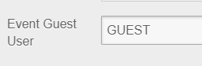

Hit Apply, and the new section will appear right above Setup:
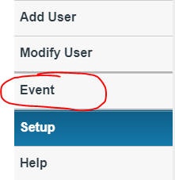

Tapping the Event section opens up Event Tracking:
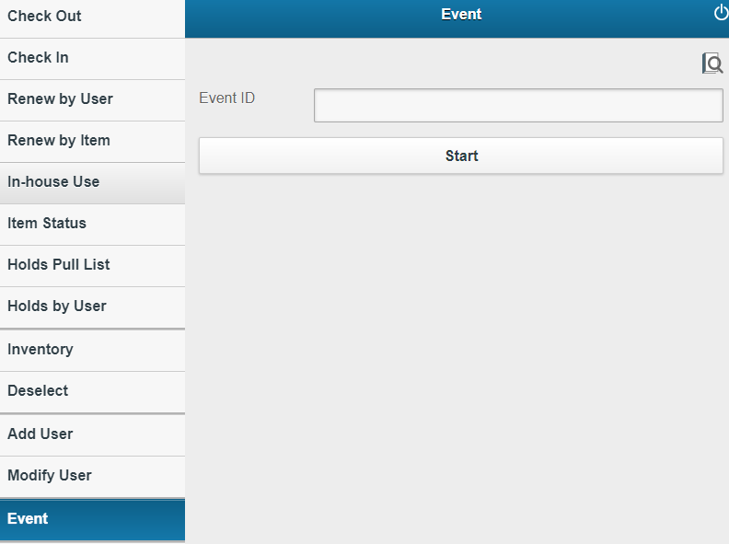

Enter in the “barcode” for the Event you created:
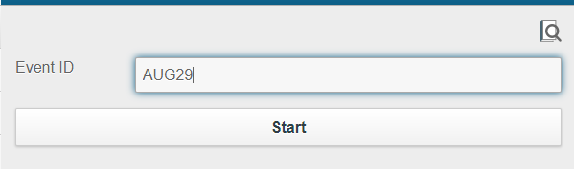

And hit “Start”:
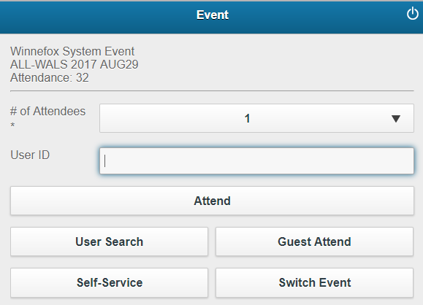

If a user comes up with a library card with them, it can be entered or scanned, and then (if anything) the “Attend” button pushed. The “Attendance” number should then increment by one.

If a user does not have their library card with them, they can be searched for using the User Search button.

Or, if they do not have it with them or do not have a library card, the “Guest Attend” button can be pressed instead. This will also increment the “Attendance” number. If there’s a group of users who don’t have cards, the “# of Attendees” dropdown can be changed to the appropriate number:
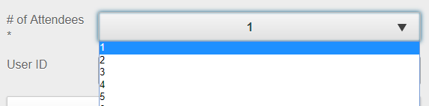
And then the “Guest Attend” button can be pushed.
Afterwards, “# of Attendees” field defaults back to 1.

If you would rather pass the tablet around to patrons and have them sign themselves in, you can select the “Self-Service” mode:
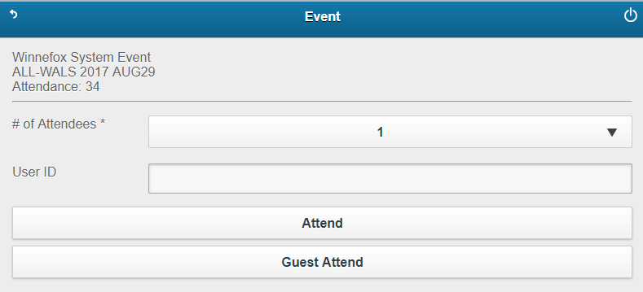
Users can either enter in their library card number, or select “Guest Attend”.

To return to the main MobileCirc app, hit the back arrow in the upper lefthand corner. You will be prompted for the password you use to log into MobileCirc and Workflows:

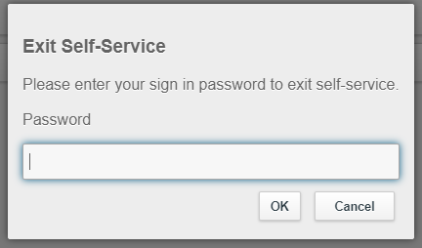

This prevents patrons from accidentally backing out of Self Service, and possibly getting into the main MobileCirc app.

